**Extract Stock Prices from BSE NSE Website**

This automation shows how to extract stock prices and Sensex index from BSE and NSE websites and sort data according to market capitalization.

**Step 1:** Open Chrome.

**Step 2:** Open BSE_NSE_Stock Excel file.

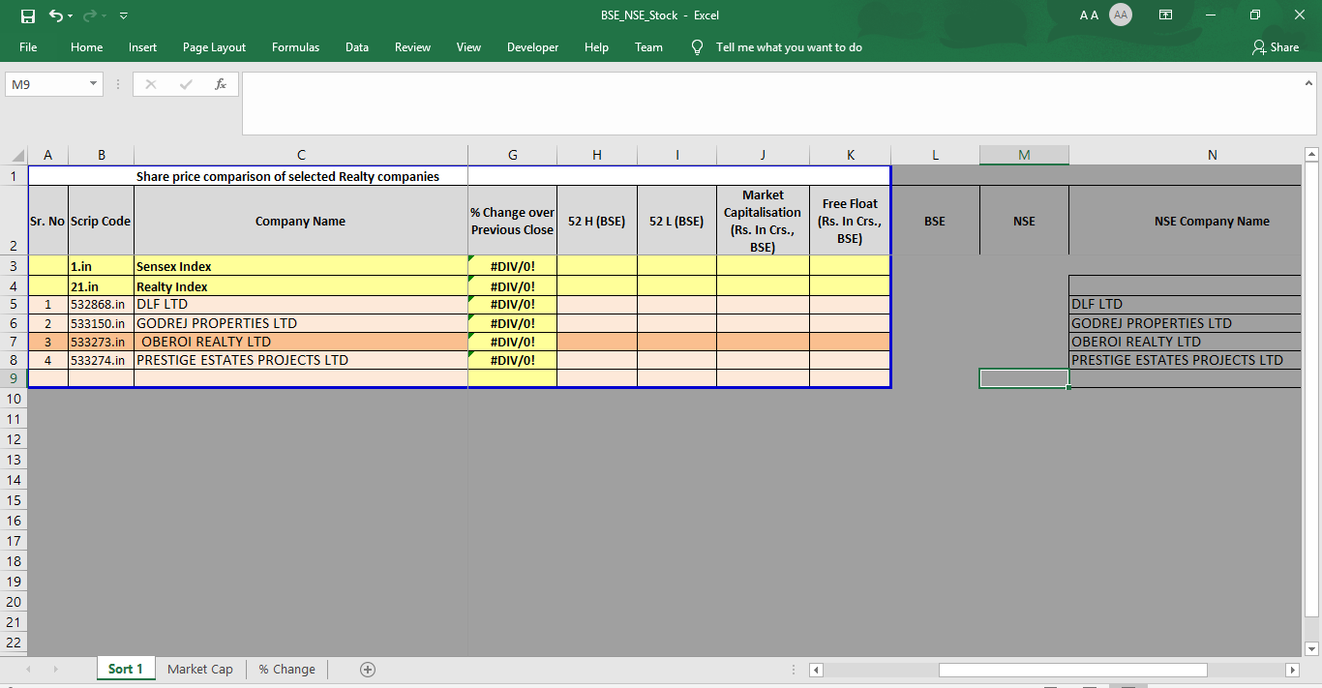

**Step 3:Double click** on **BSE_NSE_Stock.zappy** automation.

**Output**: Stock prices is extracted from BSE and NSE site and also Excel sheet is sorted according to Market capetelization and % change.

